**Project Documentation**

**1. Introduction**

**Project Title:**

Health AI

**Team Members:**

* K. Keerthana (Team leader)
* S J. Harene
* R. Prathiba

**Introduction**:

**Health AI** (Artificial Intelligence in Healthcare) refers to the application of artificial intelligence technologies—such as machine learning, deep learning, natural language processing, and computer vision—in the medical and healthcare fields.

It is used to analyze complex medical data, support clinical decision-making, improve patient care, and optimize healthcare operations. AI systems can process large volumes of data (like medical images, patient records, and genetic information) faster and more accurately than humans, helping doctors and healthcare professionals make better decisions.

• **Medical Imaging** – Detecting diseases (e.g., cancer, heart disease) using X-rays, CT scans, or MRIs.

• **Predictive Analytics** – Predicting patient outcomes, risks, and treatment effectiveness.

• **Drug Discovery** – Speeding up the development of new medicines.

• **Virtual Assistants & Chatbots** – Assisting patients with health information and routine care.

• **Personalized Medicine** – Tailoring treatments to an individual’s genetic profile.

• **Hospital Operations** – Optimizing scheduling, resource use, and patient management.

---

**2. Project Overview**

**Purpose:**

This project focuses on exploring the role of **Artificial Intelligence (AI) in Healthcare** and how it is transforming the medical field. The project highlights the importance of AI in improving diagnosis, treatment, and overall patient care. AI technologies such as **machine learning, deep learning, and natural language processing** are being used to analyze medical data, detect diseases at an early stage, and support doctors in making better clinical decisions.

The project also covers applications of Health AI in areas like **medical imaging, drug discovery, hospital management, and patient support systems**. It emphasizes how AI can make healthcare more **accurate, efficient, cost-effective, and accessible**, while also discussing challenges such as data privacy, ethical concerns, and the need for human supervision.

**Benefits:**

• **Early Disease Detection** – Identifies diseases like cancer, diabetes, or heart problems at an early stage.

• **Accurate Diagnosis** – Reduces human error by analyzing medical images, lab results, and patient data with high precision.

• **Personalized Treatment** – Provides treatment plans tailored to each patient’s genetics, history, and lifestyle.

• **Faster Drug Discovery** – Speeds up the research and development of new medicines and vaccines.

• **Improved Patient Care** – Virtual assistants and AI chatbots help patients with 24/7 support and health monitoring.

• **Operational Efficiency** – Automates hospital management tasks like scheduling, billing, and record-keeping.

**Features:**

**1. Disease Prediction**

* Input: User-provided symptoms (e.g., fever, cough, fatigue)
* Output: A list of possible medical conditions with general lifestyle or medication recommendations.
* Value: Provides initial guidance and narrows down possible causes for further medical consultation.

**2. Treatment Plan Generator**

* Input: Medical condition, age, gender, and medical history.
* Output: Personalized treatment suggestions, including lifestyle changes, dietary advice, and general medication guidelines.
* Value: Helps individuals prepare before visiting a doctor and encourages proactive health management.

**3. Conversational Interface**

* Built using Gradio, offering a user-friendly interface with tabbed navigation.
* Interactive buttons and textboxes provide a smooth, chat-like experience.

**4. AI-Powered Responses**

* Powered by IBM Granite LLM, capable of natural language understanding and response generation.
* Ensures coherent, structured outputs instead of raw model predictions

**5. Ethical Design**

* Clear disclaimers are shown in both UI and responses.
* Emphasis on informational use only, avoiding overconfidence in medical accuracy.

**3. Architecture**

**Frontend (Gradio):**

* Tab-based design with dedicated sections for disease prediction and treatment plan generation.
* Accepts structured inputs such as symptoms, patient details, and medical history.
* Provides outputs in multi-line formatted textboxes.
* Lightweight, responsive, and easily shareable via share=True option.

**Backend (PyTorch & Transformers):**

* Uses Hugging Face Transformers to load the IBM Granite LLM and tokenizer.
* Handles tokenization, tensor creation, and decoding of model outputs.
* Automatically detects GPU availability and optimizes for CUDA if present.
* Manages prompt construction to guide the model toward safe, contextual responses.

**LLM Integration (IBM Granite LLM):**

* IBM Granite 3.2 2B Instruct model is optimized for instruction-following tasks.
* Prompt engineering ensures disclaimers and medically responsible outputs.
* Supports temperature-based sampling for balanced creativity and accuracy.

**4. Setup Instructions**

**Prerequisites:**

* Python 3.9 or later

**Installed dependencies:**

* pip install torch transformers gradio
* GPU (optional, recommended for large models)
* Internet access to load the model from Hugging Face

**Installation Process:**

1. Clone or download the repository.

2. Navigate into the project directory.

3. Install dependencies from requirements.txt.

4. Run the application:

python app.py

5. Access the Gradio web interface on:

Localhost (http://127.0.0.1:7860)

Shareable public link (if share=True is enabled).

**5. Folder Structure**

project/

│

├── app.py # Main Gradio application

├── requirements.txt # Required dependencies

├── README.md # Documentation and usage guide

└── assets/ # (Optional) Icons, images, or logos for UI

This simple structure ensures readability, maintainability, and easy deployment.

**6. Running the Application**

**1. Start the application with:**

Google collab

**2. Once launched, Gradio will provide:**

* A local link for testing on your machine.
* A shareable link for accessing the app remotely.

**3. Navigate through the two main tabs:**

Disease Prediction: Enter symptoms and click Analyze Symptoms to get possible conditions.

Treatment Plans: Enter patient details and click Generate Treatment Plan for suggestions.

**4. Results are displayed in clear, formatted text areas for easy reading and copying.**

**7. API Documentation**

Currently, the application is designed as a UI-based system. However, future enhancements can add REST APIs for external integration. Example APIs could include:

POST /predict-disease

Input: JSON containing user symptoms.

Output: JSON with possible conditions and general recommendations.

POST /treatment-plan

Input: JSON with patient condition, age, gender, and history.

Output: JSON with treatment plan suggestions.

These endpoints would allow integration into mobile apps, EHR systems, and telehealth platforms.

**8. Authentication**

Current Version: No authentication (open demo).

Future Plans:

Token-based authentication (JWT, API keys).

Role-based access for patients, doctors, and admins.

Secure storage for patient interaction logs.

**9. User Interface**

Tabbed Layout: Two tabs for separate workflows (Disease Prediction & Treatment Plans).

Inputs:

* Textbox for symptoms.
* Dropdown for gender.
* Number field for age.
* Textbox for medical history.

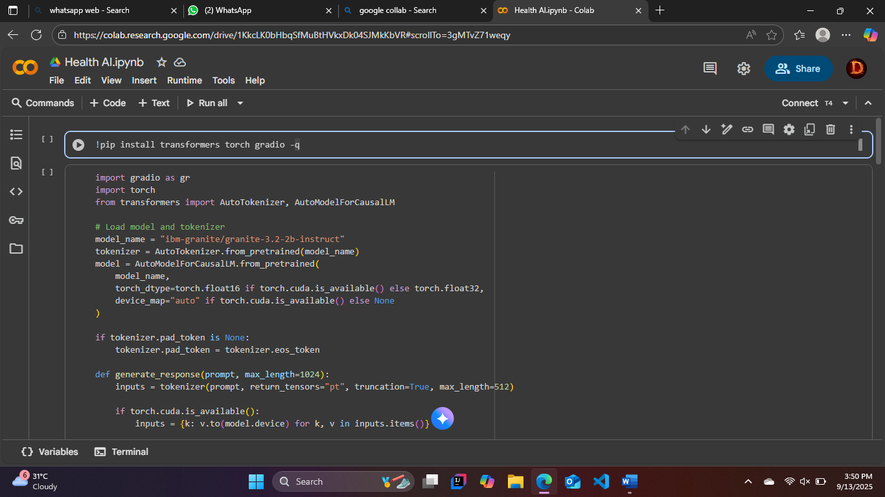

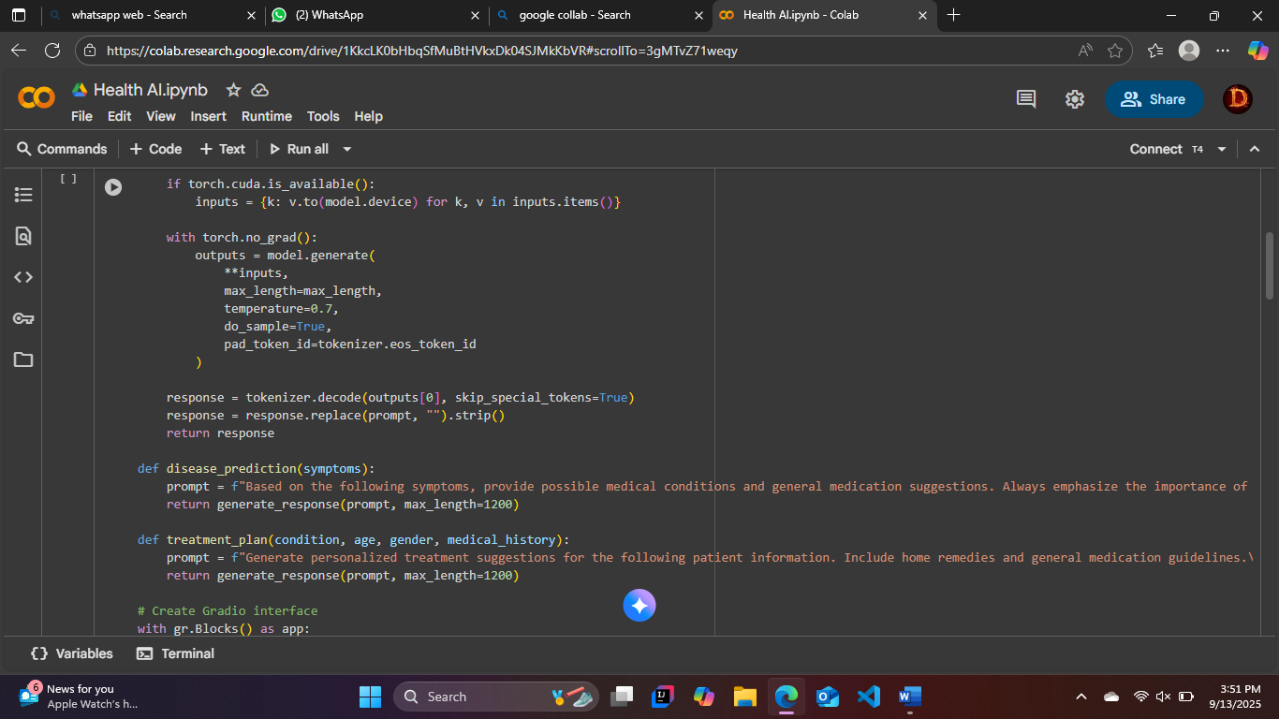

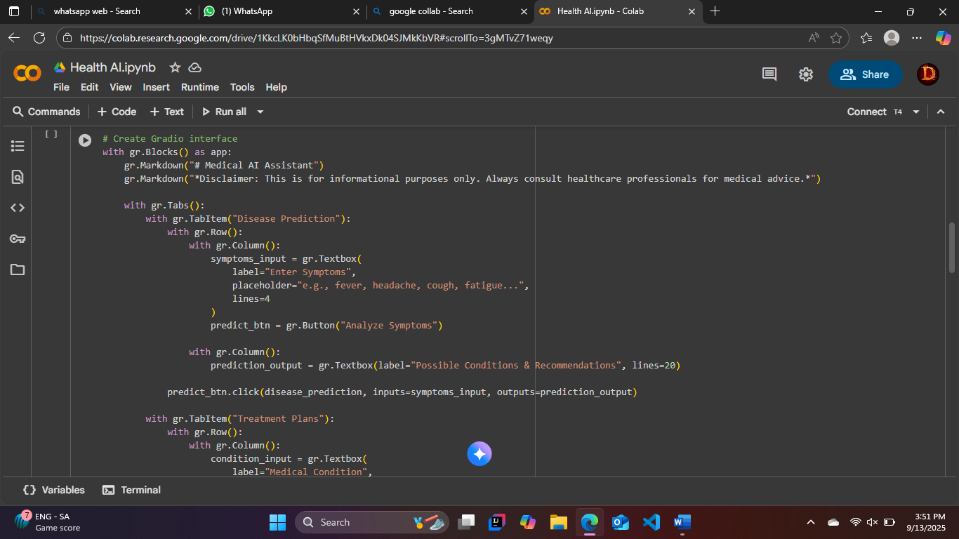

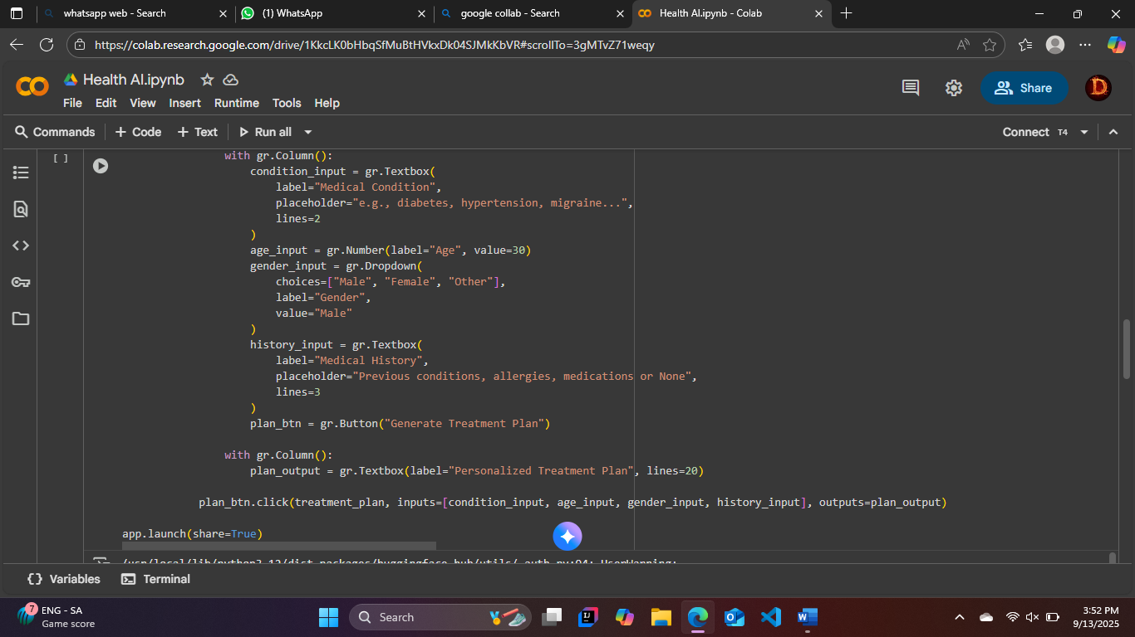

Outputs:

Multi-line textboxes for results.

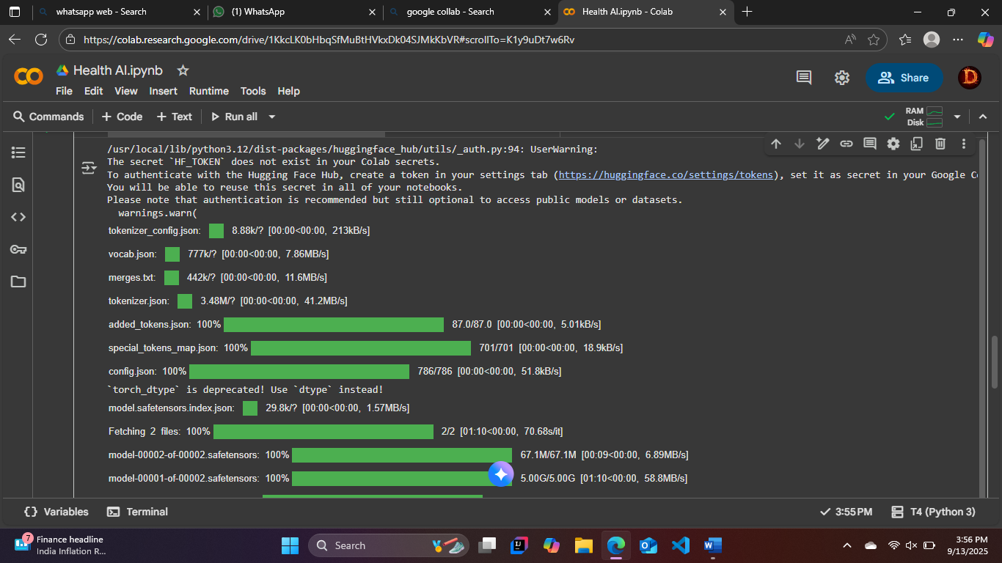

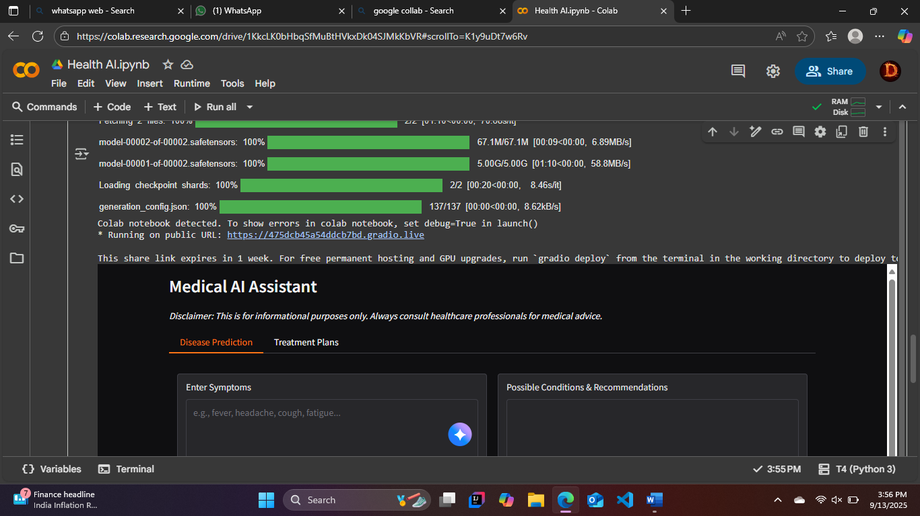

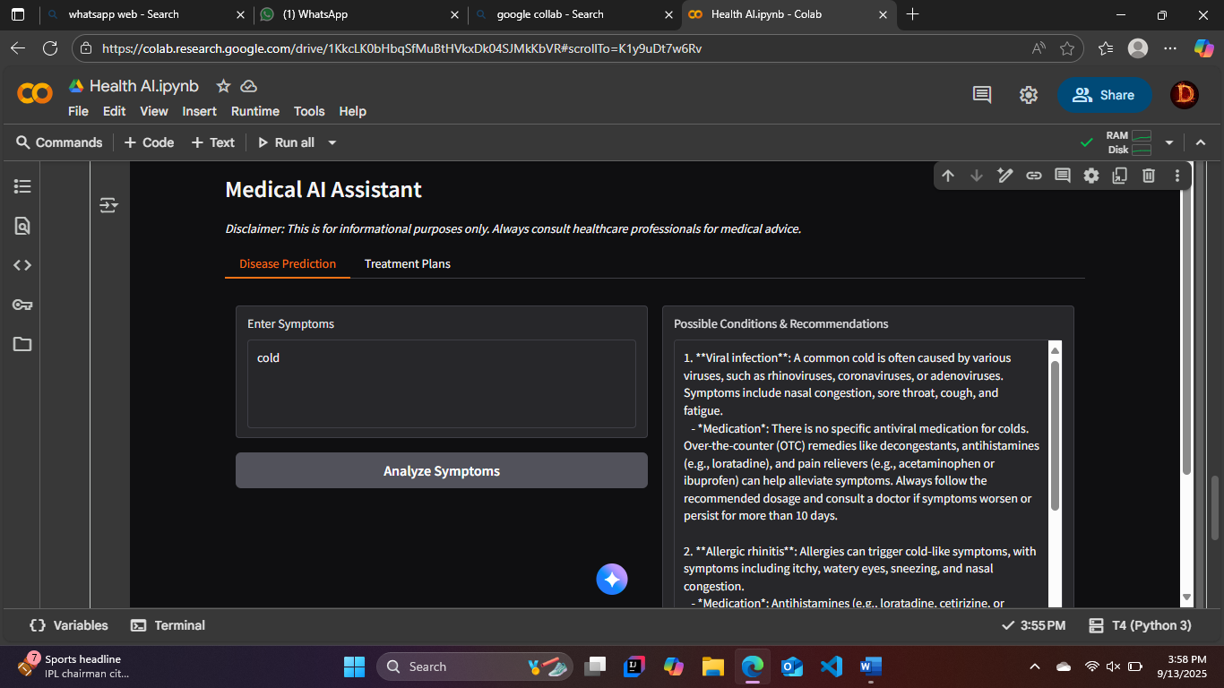

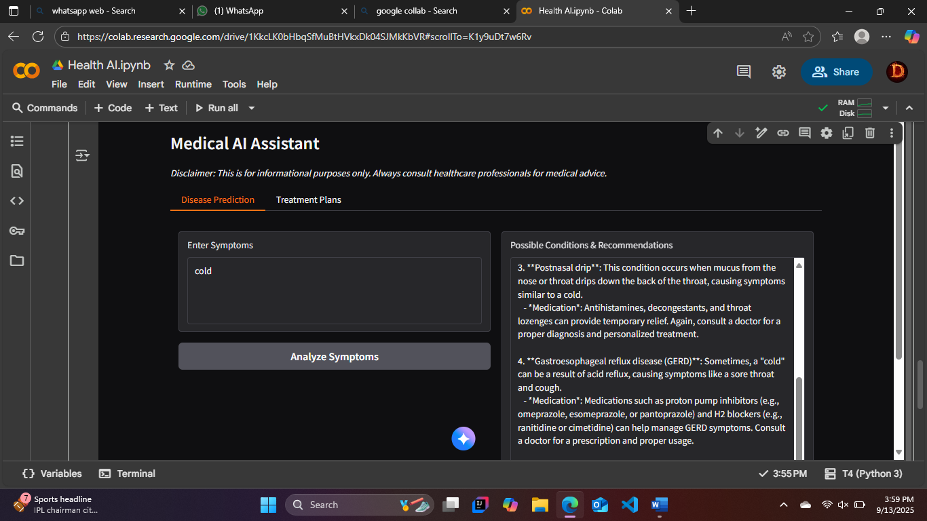

**Interaction:**

* Simple, intuitive, and mobile-friendly.
* Emphasis on clarity and accessibility.

**10. Testing**

* Testing performed includes:
* Unit Testing: Validation of prompt construction and tokenization.
* Manual Testing: Testing across different symptom/condition inputs.

Performance Testing: Comparing GPU vs CPU performance.

**Edge Case Handling:**

* Empty or incomplete inputs.
* Extremely long text entries.
* Non-standard characters.

Outcome: The system reliably generates responses but requires disclaimers for accuracy.

**11. Known Issues**

* AI responses may vary depending on input phrasing.
* Outputs may be too generic for complex or rare medical conditions.
* Long prompts sometimes exceed model token limits, leading to truncated responses.
* LLM knowledge may not reflect latest medical research.

**12. Future Enhancements**

* Integration with Medical Knowledge Bases (e.g., WHO, CDC, PubMed).
* Patient Session History Tracking for continuous monitoring.
* Multi-Language Support to expand accessibility globally.
* Risk Level Classification to flag urgent cases.
* Voice-based Interaction for hands-free usability.
* API Exposure for mobile/enterprise healthcare systems.
* Fine-tuned Models trained specifically on medical literature.